Important to note
No group sponsored this testing. It was all coordinated and paid for by myself.

Also, I delayed sharing these results for a very long time, in hopes that Berkey could correct it or at least to give them a chance to resolve this issue with a refund. However, I am now sharing it since many people are interested in my testing results, process, and extremely poor customer service experience.

Timeline of interactions with Berkey
3/5 Ordered a Berkey Royal plus a stand and 2 fluoride filters (and 2 shower filters). $454.06
3/9 Our Berkey dealer from the group buy notified us that the Royal was on backorder so we needed to upgrade (or downgrade) so we upgraded to an Imperial. $22
3/22 Picked up Berkey system
3/23 Dropped off sample from my tap water and Berkey filtered water to compare fluoride levels. $30
3/24 Received results and fluoride was only reduced 77%, not the 95-99.9% they advertise
3/25 I talked to Daniel from Berkey customer service and he told me to get a pool PH test from Walmart and red food coloring. He told me if the PH is under 6 that it won't work as efficiently. He said the red food coloring test will show if the black filters are working since they assist with fluoride filtration, not all of it is the fluoride filter. He offered to refund it if we can't resolve the issue.
3/27 Ordered PH test strips from Amazon since that seemed like it would be more reliable than the pool kit at Target. $10.40
3/28 Bought red food dye from Kroger and realized 1 filter and 3 white plugs were defective. $3
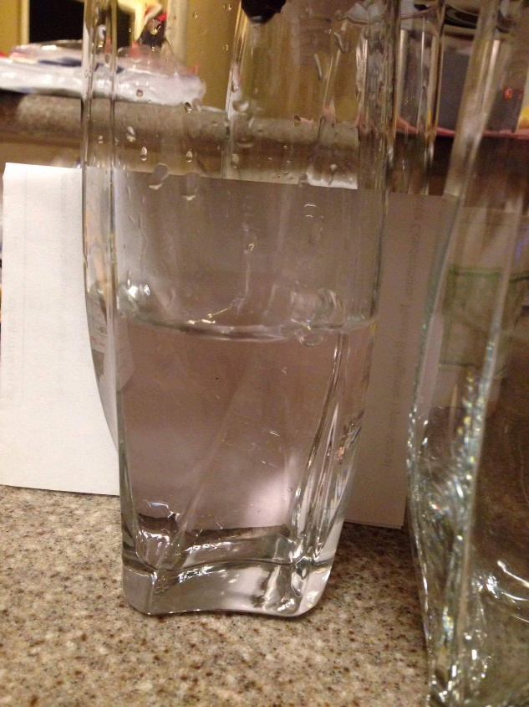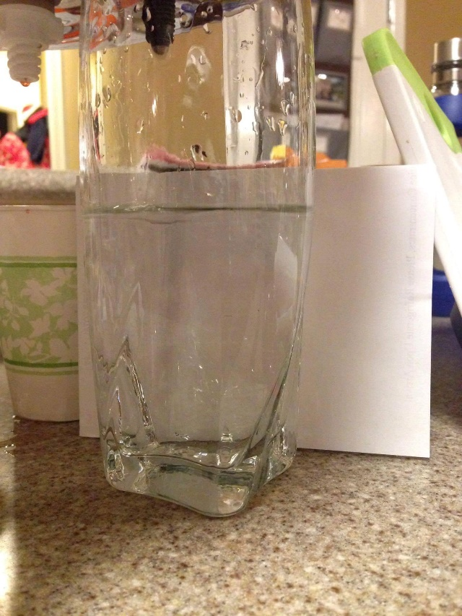
3/29 PH test strips arrived
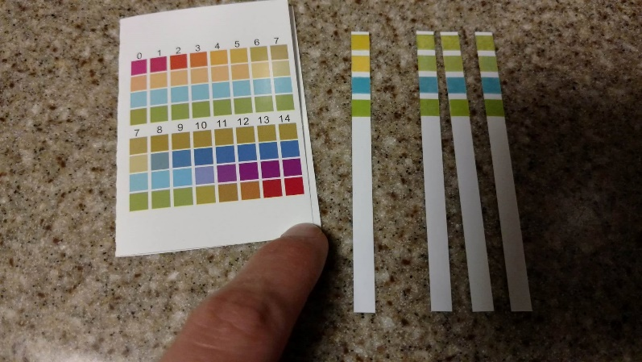
Ozarka is the left test strip, looks like 5. My tap water are the other 3 test strips. Not a great match but seems closest go 7.
4/1 I called Berkey and spoke to Tiffany and she said they would replace the defective black carbon filter and the white plugs. I just needed to email them proof of purchase. She also said water should be between 5-7 PH for optimum fluoride filtering but I challenged her on that because their website says this. She said their test results say 5-7, so I asked why their FAQ is different and she said it needs to be updated.
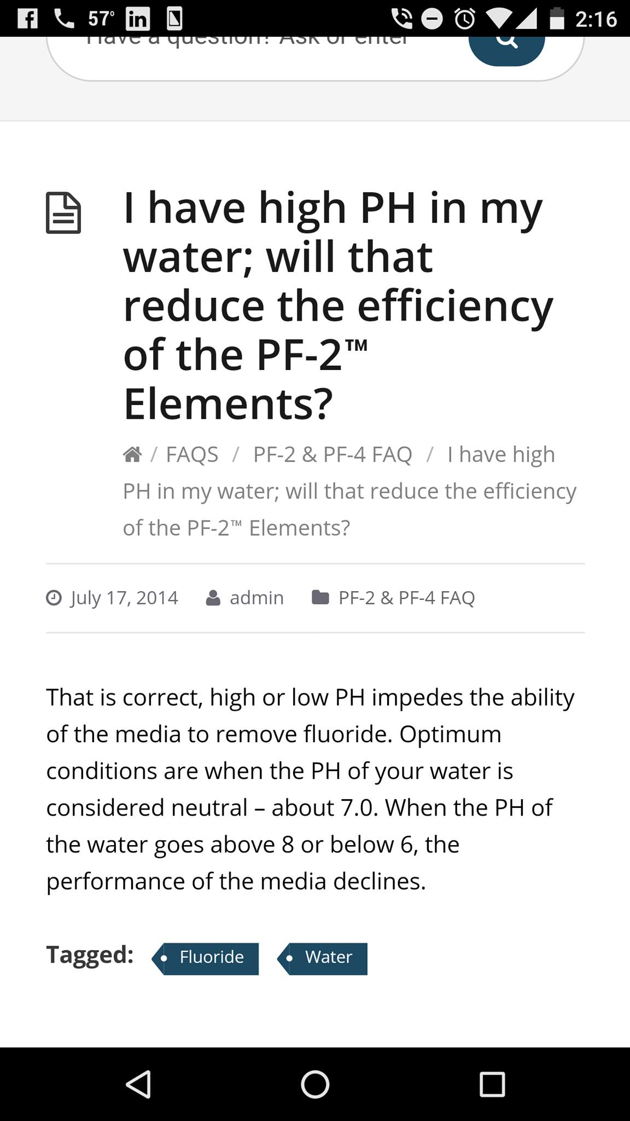
4/1 Requested proof of purchase from my dealer.
4/4 Received receipt from my dealer.
4/4 Emailed Daniel from Berkey
Hi Daniel,
I spoke with Tiffany Friday and she said to email you my proof of purchase to get the black carbon filters and white plugs replaced, which failed the red food dye test. These are brand new, I only filled it once before the test. (My PH is 7, by the way.)
Please let me know if you need anything else and advise when the replacements will arrive.
My address is: XXX
Best Regards,
4/5 They emailed me return instructions for the defective parts however they wanted me to pay return shipping. I objected since I had contacted them within 10 days of receiving my product and had been talking to them/ troubleshooting, so they agreed it was an error and they provided a return label.
4/12 Received the replacement parts and re-did the red food dye test and it passed.
4/13 Dropped off the 2nd Berkey sample to re-test the fluoride. $15
4/18 Received the results and it was only a 80% fluoride reduction, hardly any improvement from the original test.
4/19 Email to Daniel:
Hi Daniel,
I received the fluoride test results and the results aren't much better after replacing the defective black carbon filter and the plugs. I am getting an 80% fluoride reduction.
Based on this, I am considering returning it but wanted to reach out to see if there is any additional trouble shooting to do first.
Thank you,
4/19 Daniel’s response:
Did the test mention the PH level of your water? The reason I ask is because at lower PH levels, the fluoride filters do not work as effectively. Follow this link for an explanation.

If the test did not mention what your PH level is, then a standard pool test kit can tell you what it is.

Thank you,

4/19 My second email to Daniel
Hi Daniel,
Yes, I did this before you sent the replacement carbon filter. The pool test showed PH = 7 so based on the article it is not too low.
Please advise.
Thanks,
4/20 Another email to Daniel (still no response)
Hi Daniel,
I wanted to follow-up to see what you suggest. Is there any test to determine if the fluoride filter is defective? Since one black carbon filter was defective, it makes me wonder about the fluoride filters.
Thanks,
4/20 Daniel’s reply
Once your PH reaches 7 is when it will start experiencing diminishing results for the fluoride filters. The only way to test the effectiveness of a fluoride filter is via a water test.

Thank you,

4/20 My reply to Daniel
Daniel,
Okay and since I did the fluoride test and the fluoride filter is not filtering at your claimed/ advertised level, can you send me replacements so we can see if that's any better?
Thanks,
4/22 Another reply to Daniel (still no response)
Hi Daniel,
I wanted to check back with you. Since 1 carbon filter was damaged in shipping or defective from production, couldn't one of both of the fluoride filters be damaged/ defective too??
Thanks,
4/25 Daniel’s reply
It is highly unlikely that the fluoride filters are damaged, merely that they are experiencing diminished effectiveness due to your PH balance. Due to this, replacing the product is not advisable as it would not fix the problem, since the issue is with the PH balance of the water.

Thank you,

4/25 My reply to Daniel
Daniel,
Can you tell me why it's highly unlikely? I don't understand why the black carbon filter could be defective but not the fluoride filter?
Thanks,
4/26 Daniel’s reply
It is possible, however it is more likely that the issue is caused by the PH level rather than the filter actually failing.

5/4 Dropped off a tap water sample to test my PH. $15
5/4 My reply to Daniel
Daniel,
To confirm my pH level, I dropped off a sample today to the local health department since that will be more accurate than the home DIY color match test that I got. I will update you once the results come back.
Also, please review these videos, based on feedback I've gotten from other Berkey owners, the fluoride filter that is going at constant stream doesn't seem right. They said it should be filtering, which takes some time. The carbon filters seem to be at an even speed.
Please advise.
5/6 Daniel’s reply
It is not abnormal for filters to flow at different rates, as it can vary greatly depending on the specific composition of the media within both the Black Berkey Elements and the Fluoride Filters.

Thank you,
5/6 My reply to Daniel
Hi Daniel,

That's interesting.

I'd like to return my Berkey and filters. I got the result back and my tap water PH is 7.82. When I purchased it, that was within the range according to your site (6-8), but now you've changed it to 5-7 for some reason. This seems strange (especially since my health department says 6.5-8.5 is normal so you have a very narrow range for what your filters work for, 6-6.5 PH).

Please let me know the process.
5/9 Daniel’s reply
It looks like your purchase was made through one of our authorized distributors, so you will need to contact your distributor to return your product, as the transaction was made through them.

Thank you,

5/10 Requested refund from our Berkey dealer. (She mentioned - I haven't heard back from them yet, my original rep left, so all her accounts are being shared with the remaining 2 account reps and they are so swamped they said to me yesterday.)
5/31 Still no response from Berkey…
6//1 I sent this summary to my Berkey dealer in hopes that it will help progress this case.
6/2 My Berkey dealer sent the summary to them. They said they will review everything and be back in touch.
6/7 Still no response from Berkey… my dealer said “I have emailed AND called them again today, no one answered so I left another voice message. Part of the problem is I don't have an account rep right now, my former rep left the company and no one is handling my account, like it seems like I am being ignored, and I am getting very impatient and irritated by there lack of response and the time it is taking them to get things figured out.”

So I emailed Daniel myself
It has been a month since I requested the refund of my Berkey system. I reached out to the distributor and provided very detailed information of our conversations/ troubleshooting/ testing. She said her account rep left the company and that she hasn't heard back from you all despite her continued efforts.
Please let me know what is still needed for this return. This seems unacceptable and I am disappointed in the lack of customer service. When I talked to you the first time, just 3 days after getting my Berkey, you assured me a refund if we couldn't resolve the issue. I don't understand why you aren't following through on that.
6/8 Daniel’s reply
It is my understanding that you wish to return the product. Since we are the manufacturer, and not the company which you purchased your product from, we cannot accept your return as it must be done through that company. As the manufacturer we cover manufacturing faults, but we cannot cover returns on orders not done directly through us.
If you have any questions, here is a link our returns/warranty policies.
6/8 My reply to Daniel
Right, you told me to go through the distributor and I did, a month ago. Why won't you respond to her so we can all move forward?
6/8 Daniel’s reply
The return is processed entirely through the dealer, meaning they don’t need our permission or knowledge to process or not process your return. That being said, please notify me which dealer you are using and I may contact their temporary account manager so they can confer with them.
6/8 My dealer said she FINALLY was able to speak to her new rep. She sent him my summary and he will review it and get back to her about what type of refund they will offer. He said that theirs is a chance they’ll take a 20% restocking fee but with my documentation she is hopeful they will provide a full refund.
6/9 My dealer said that they are moving the claim to the claims department from her account rep.
6/14 My dealer received this email
Upon approval, the returns department will issue you full store credit on the items purchased except on the Berkey base (there will be a 20% restocking fee on this). Also, you or the customer will have to send back the entire system to our location before we apply this store credit.

Please call me if you have any questions or concerns. Thank you for choosing Berkey.
Warmest Regards,
Dami
… A store credit is definitely not what I want so she replied to them informing them that doesn’t help… This story will be updated once we finally resolve this.
6/15 My dealer received this email
I apologize for the mix up in the earlier email. The breakdown I gave you was an optimistic resolution to the return request. However, based on the return policy, your return request will be rejected.
NMCL does not allow for return based on buyers’ remorse. We do handle returns for incorrect, missing or damaged items. If a client decides the system does not work to their satisfaction this would be classified under buyers’ remorse. A return such as this is regrettable but it is the cost of doing business.

I would also point out that PF-2s are Fluoride Reduction filters. We do not make any claims that PF-2s remove all Fluoride. Please call me if you have any questions or concerns. Thank you for choosing Berkey.
Warmest Regards,
Dami

This is so strange that they deny making claims, check out their Facebook page. (They did scrub their website of any claims but other owners and dealers have said they have seen claims made too.)

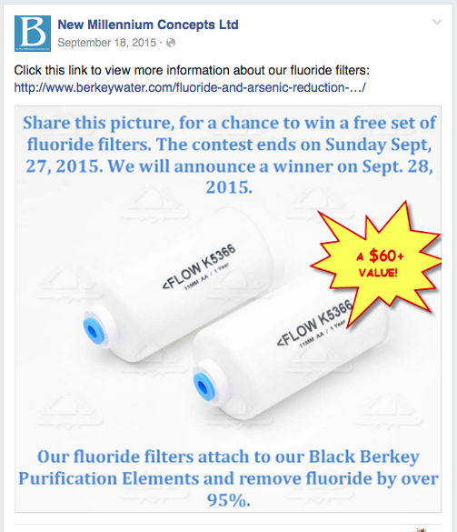

I spent $365.21 on a Berkey system that I can’t use because it doesn’t filter fluoride sufficiently and it cost $73.40 (not including tolls and gas, 130 miles) for testing and troubleshooting. I would not have purchased this if their website had been correct and clear up front about the PH limitations. I’m frustrated by the false advertising (changing the optimum PH from 7 to 5, after I told them my results) and then their extreme lack of response for my refund request.

Now their website has been updated to show the new PH requirements.
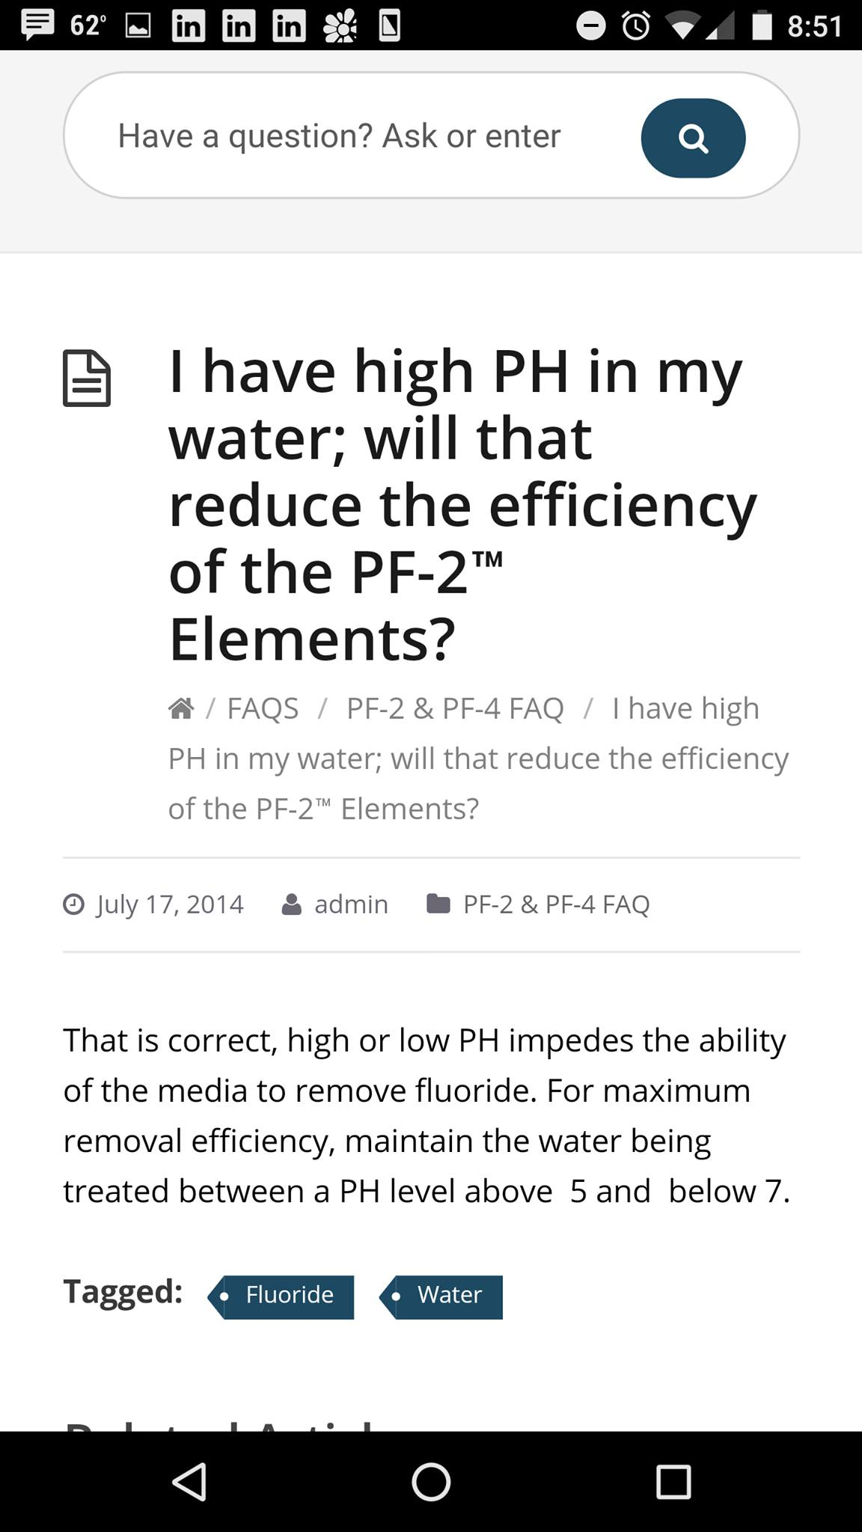

The PF-2 test results say “Note that the material is most efficient between a PH of 5 and 7 with PH=5 preferred.” However PH 5 is acidic and I can’t imagine any tap water being that.

Also, their website mentions that initially their carbon filters help a bit with fluoride reduction, see here, which means that my results could have been a bit inflated and with continued use, the fluoride reduction could be even lower. That is why these test results show a 99.9% reduction in fluoride, without even using the fluoride filter.

My results
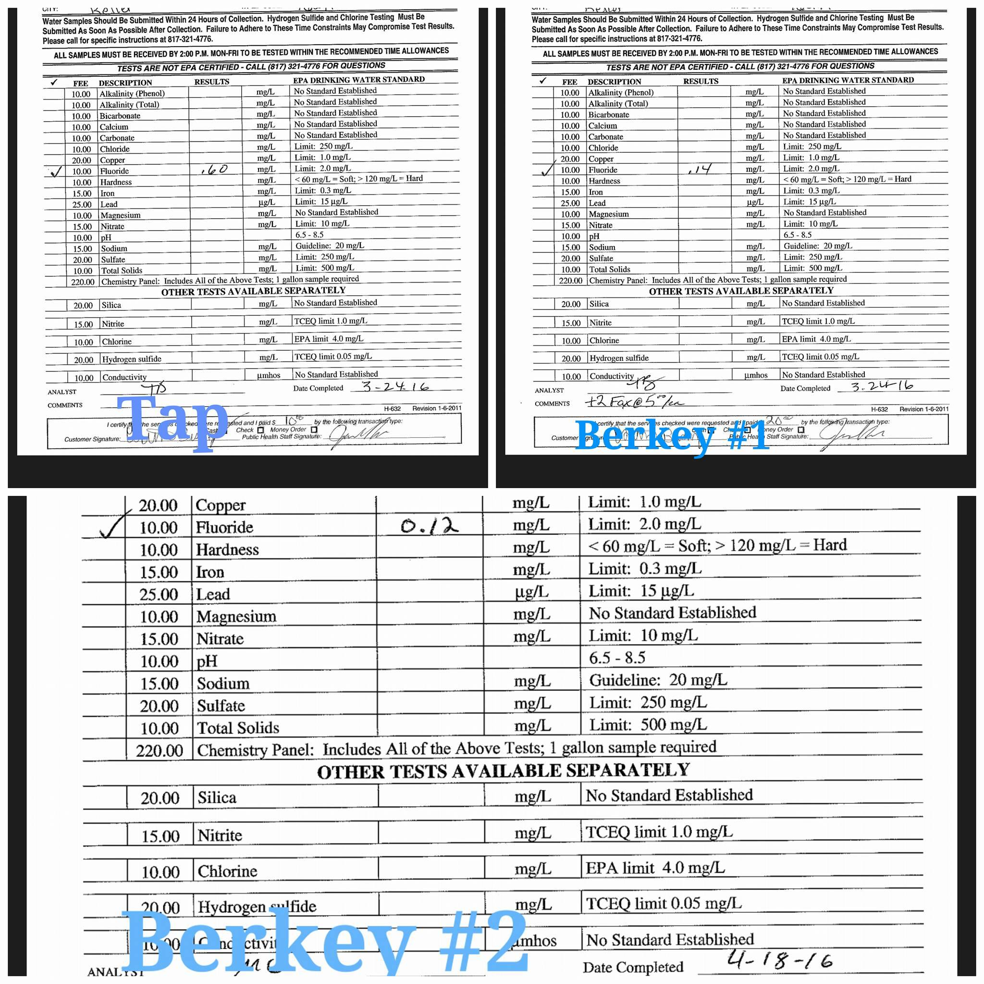

What should you do?
If you have Berkey filter results to share, email me at filter.results@gmail.com.
If you haven’t tested yet, I’d suggest doing the red food dye test first to ensure you don’t have any defective or incorrect installed pieces to your system. This is also cheaper to do up front rather than having to repeat the fluoride testing.
If you are considering buying a Berkey system and are concerned about fluoride elimination, test your PH first, this should be ~$10 at your local health department. This will determine if you are within the recommended PH range by Berkey for optimal fluoride reduction results. If you are not within that range, the Berkey with fluoride filters will reduce fluoride but will likely not be 95-99.9%. If you are not within their suggested PH range, you may want to consider an RO system.

